Are you in your Resilient Zone?
How to be your best self during and after the COVID-19 crisis

Learn about the common human reactions to stressful/traumatic events, such as the COVID-19 crisis that affect the mind, body, and spirit and how to apply Community Resiliency Model® (CRM) skills. CRM are a set of trauma-informed and resiliency-based wellness practices that helps individuals learn to read their nervous system to return to their zone of well-being, called the Resilient Zone through the use of accessible wellness skills. In this framework, resiliency is defined as “an individual’s and community’s ability to identify and use individual and collective strengths in living fully with compassion in the present moment, and to thrive while managing the activities of daily living.” (Miller-Kara, 2020)
In this CRM introductory session, participants are encouraged to share resiliency resources and practices they are currently using during this difficult time.
Objectives: By the end of the online session, participants will have
- An understanding of the biology and neurophysiology & impact of toxic stress and traumatic event, such as the COVID-19 crisis.
- Foundational skills on how to apply biologically-cased wellness skills, which can help re-set and stabilize the nervous system during difficulty times.
- Knowledge of how resiliency can be restored or increased using CRM practices.

Presented by:
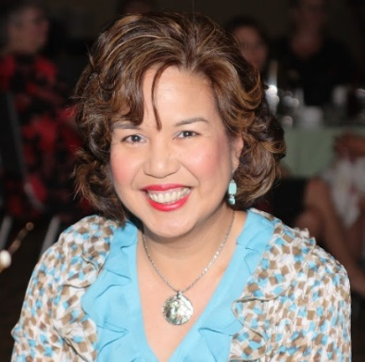
Dr. Ernelyn J. Navarro, DM, LCSW, BCC, CDWF
Many IEBfC members know Dr. Navarro or “Ernie” as the former Board of Director Chair/President of the California Breastfeeding Coalition and served as co-chair of the annual Summit. Ernelyn worked in health care since 1985 as a social worker and served in various leadership positions since 1990. She is currently the Manager of Community Programs and Services at St. Mary Medical Center, Apple Valley, CA. She was recently appointed by the hospital’s executive leaders to develop and provide “boots on the ground” mental health and well-being services for their front line hospital employees during the COVID-19 crisis. She is also an Adjunct Faculty at the University of Southern California’s Doctor of Social Work program. After returning from a Humanitarian Mission to the Philippines with USC’s School of Social Work to assist with the Typhoon Yolanda in 2013, she enlisted to serve as a Red Cross Disaster Mental Health volunteer in Riverside County for 4 years. Dr. Navarro is a Certified CRM® Teacher (from the Trauma Resource Institute) and Certified Daring Way™ Facilitator (based on Dr. Brené Brown, PhD’s research on shame and vulnerability).

